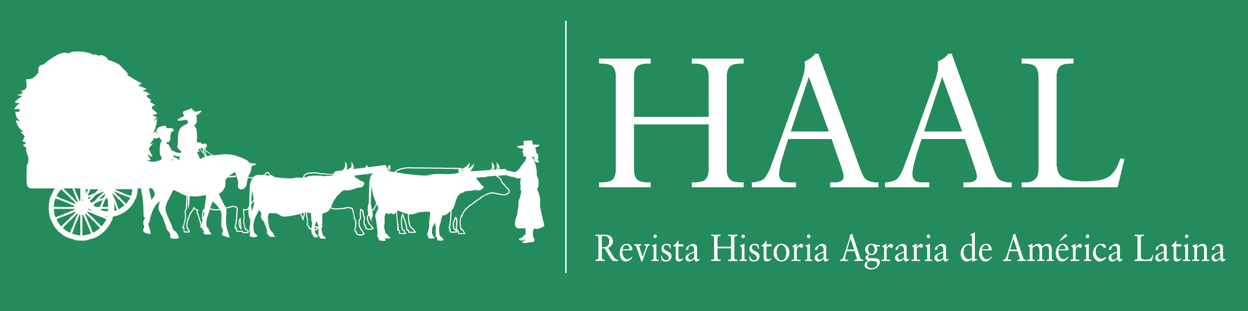

Statement of Originality and Consent

I / We …………FULL NAMES IN CAPITAL CASE hereby formally declare that the article manuscript entitled “……………………………………..,” which I /we have submitted for publication to the journal *Historia Agraria de América Latina* (HAAL), is an original work, entirely done by me/us. I /we also declare that the said manuscript is not under evaluation by another journal, and that I/we will not submit it to another journal while under evaluation by *Historia Agraria de América Latina* (HAAL).

Likewise, I / we declare that the aforementioned manuscript has not been previously published (except for a preliminary version as working paper or conference proceeding), and that it does not include any parts, sections or paragraphs substantially similar to other works I / we have published in other journals. In addition, I / we declare that I / we will be responsible for providing copyright permissions for any photographs or images included in the manuscript, if accepted for publication.

I /we also declare that I / we give my/our consent so that the journal *Historia Agraria de América Latina* (HAAL) publishes the aforementioned manuscript free of charge as an article in the open access journal’s website: www.haal.cl

I / We sign this in CITY, COUNTRY, on DATE

FULL NAME(S) SIGNATURE(S)

ORCID: